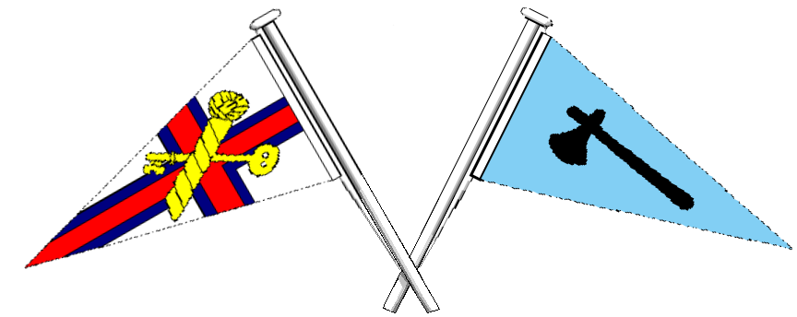

Axe Yacht Club & K.E.Y.S.

2026 River Race Programme

General Handicap for all Dinghies :- River Shield

Class Racing for Axe One Designs - Jack Drew Cup. Mirror Class - Marine Trophy. Scow Class - Scow Tankard. HC excluding Class Groups – River Pot. Cadet Series - Cadet River Cup. River Pursuit Plate.

Start line - Coronation Green, Axmouth.

Race 1. Weds 29th April (H.W. 18:36 – 3.6m) Start time 18:00

Race 2. Saturday 16th May (H.W. 19:35 – 3.9m) Start time 19:00 (River Pursuit)

Race 3. Saturday 30th May (H.W. 19:13 – 3.6m) Start time 18:45

Race 4. Saturday 13th June (H.W. 18:09 – 3.6m) Start time 17:45

Race 5. Monday 29th June (H.W. 19:30 – 3.5m) Start time 19:00

Race 6. Sunday 12th July (H.W. 17:49 – 3.5m) Start time 17:30

Race 7. Saturday 18th July (H.W. 10:45 – 3.7m) Start time 10:15 (AYC Regatta Cup)

Race 8. Weds 29th July (H.W. 19:52– 3.6m) Start time 19:15 (Shower Flow Cup)

Race 9. Sunday 2nd Aug (H.W 09:55 – 3.6m) Start time 09:30

Race 10. Weds 12th Aug (H.W. 19:55 – 4.0m) Start time 19:15 (Round the Island)

Race 11. Thursday 27th Aug (H.W. 19:28 – 3.7m) Start time 19:00

Race 12. Weds 9th Sept (H.W. 18:45 – 3.9m) Start time 18:15

Race 13. Thursday 24th Sept (H.W. 18:15 – 3.5m) Start time 17:45

Race 14. Weds 7th Oct (H.W. 17:20 – 3.5m) Start time 16:45

Early season Pimms at GBH, Sun 24th May 12:30. River Brunch, Sat 6th June 09:30. *Harbour Race Cup, Sunday 21st June, Start time 11:45 (*Non series race). Evening Pimms at GBH, Friday 26th Jun,16:00. Brunch at Vicarage Creek - Saturday 19th Sept,10:30. Sunday 11th Oct 18.00 – End of Season Supper.

